Hello, this document is intended to explain what the eve-ng fork is.
I want to say right away that I respect the work of eve-ng main developers. But their code leaves a lot to be desired if they really do as I've seen in the community version.
And also, as the main teacher in the system and network administration stream, I was not very happy with the fact that I had to administer 80+ eve-ng servers for each user.
So it was decided to see what I can do with this version, of course I do not add the full functionality of eve-ng pro, I do not need it, it was enough for me that I could make many users and divide them into separate subnets that each user would not interfere with each other.

English is not my native language but I will try very hard to describe everything in details about the functionality and some points.

And so, I provide eve-ng as a tar archive of the unetlab folder as well as an entire virtual machine from vsphere.
In the case of the unetlab folder I will describe later, but this is the last resort when you are too lazy to re-deploy the virtual machine.

I won't describe trivial things like where you should find images for eve, how to use unl_wrapper and so on, it's the base, you need to know that. And if you don't know, you can look at the main source of eve-ng, everything is very clear there.

LOGINS/PASSWORD

cli - root/eve
web - admin/eve
db eve-ng - mysql -u eve-ng -p / eve-ng
db quacamole - mysql -u guacuser -p / eve-ng
web guacamole - it is not possible to make a password for guacamole as it consists of the eve-ng password cache.

NETWORK

The first thing I'd like to talk about is the initial setup of eve-ng, specifically how to set up the network interfaces and how to use them.
At the moment we have these interfaces, eth0 is for eve-ng management, we don't use it at all in the labs, and eth1 which is a trunk with multiple vlans.

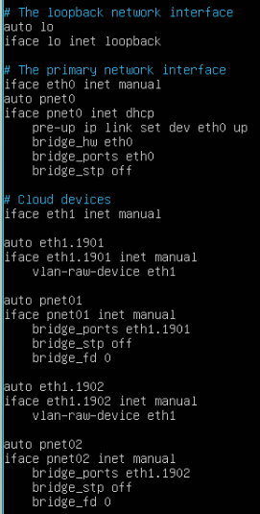

So pnet is our cloud interfaces in eve-ng, pnet refers to eth1.№VLAN, and it already refers to eth1 under the VLAN tag.
Of course you can use regular pnets without VLANs by removing eth1.#VLAN from the /etc/network/networking completely. Or make a completely custom configuration, this should not break the logic of how the networks work, the main thing is that they should be called pnet№.

INSTALL UNETLAB.TAR

You can just download unetlab.tar and unzip to the /opt folder in order to replace the files in the unetlab folder. But in this case you will also need to create a table in the eve_ng_db database.
Let's execute the commands:
mysql -u eve-ng -p
eve-ng
use eve_ng_db;
CREATE TABLE user_clouds (
id INT AUTO_INCREMENT PRIMARY KEY,
username VARCHAR(255) NOT NULL,
cloudname VARCHAR(255) NOT NULL,
pnet VARCHAR(255) NOT NULL
);
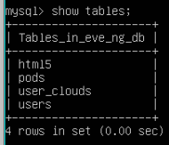

That's basically it.

WEB

When you go to web eve you may notice that only html5 authentication is available, what is it and why is it.
We use this authentication at college because it allows you to see which user and how many users are connected to which node, as well as the connection time. I have not yet encountered broken nodes that do not open, I think there are none.
Of course, you can just uncomment the old authentication line then you will have regular putty and VNC working.
/opt/unetlab/html/themes/adminLTE/unl_data/pages/login.html
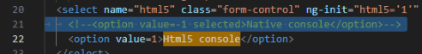

Also, one of the advantages of html5 is that it skips the need to install the eve-ng package with putty vnc and so on.

In total, there are 3 types of users in eve, but I haven't implemented user yet, you can try to use it, it has a minimum of functionality, an administrator, essentially a teacher who sees everything and does everything, an editor for students or similar users who can create lab work, share them, and so on, but not manage users or networks or list nodes.

In this implementation, labs are divided into 3 types:
1 - private, when you created a lab, you and all administrators can see it.
2 - colloborate, when people you entered in the line can enter your lab and work together.
3 - sharing-private, when a user shares a lab with other users, but if colloborate is not selected, then the user can only open private, in some form this is necessary for publishing college lab work.

USERS

Well, users are users, there is nothing special to analyze here, the maximum number of users according to my calculations is 200+ (256 port = 1 user)(~32760 port start)
If you performed installation/change via unetlab.tar, then it is better to recreate the admin user, there is something wrong with it, I think it is because of POD -1.

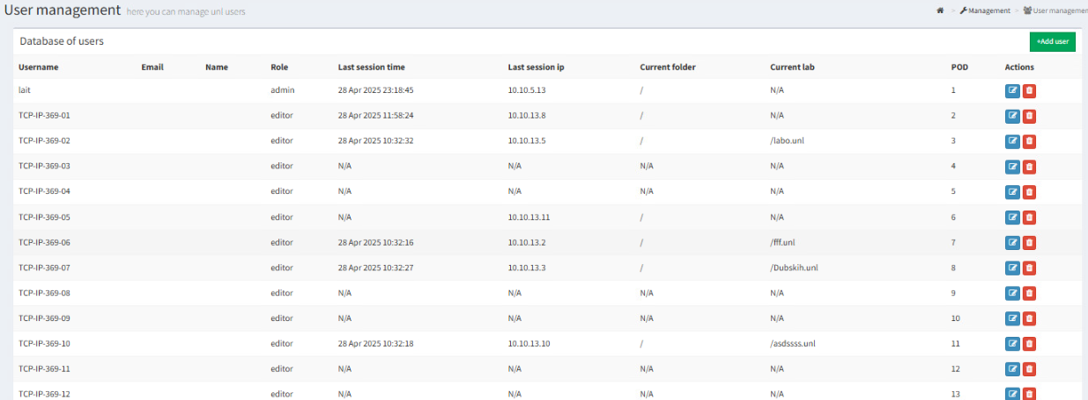

Example of publication design.

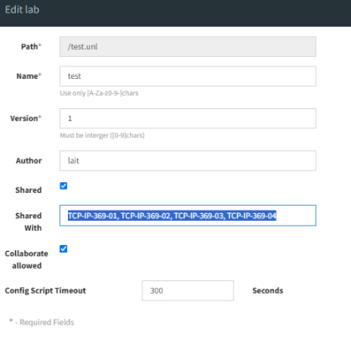

DEVICES

The number of nodes per user is 256, you can also exit the lab while nodes are running in one lab and enter others. The button to stop all nodes has been moved. Of course, you need to be careful with the nodes, because if you have thousands of nodes running, the page will take a long time to load.
To be honest, this page has almost lost its meaning because of quacamole.
Unfortunately, I don't have any user quota restrictions, so this page is more for understanding who has what running and how much.

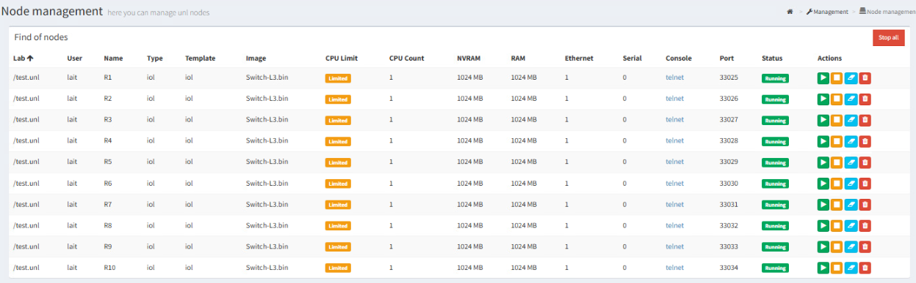

CLOUDS

The Cloud tab is intended to link the Cloud name that will be displayed to the user in the lab and the pnet name. In general, from the above it is clear that for the user you can define several clouds and name them differently

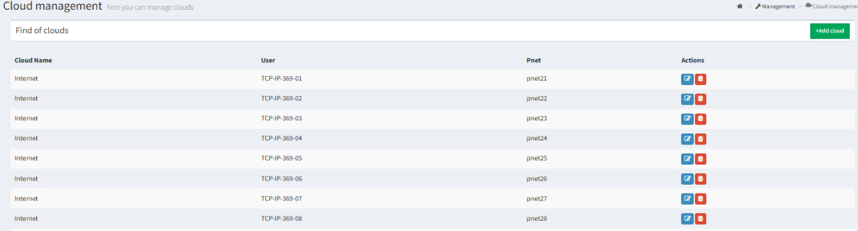

GUACAMOLE

I will say right away that the token breaks when the server is rebooted and the user automatically logs into the web, you will simply have an entry to the guacamole account when you click on the node. The only way out is to log out of the account and log in again.
The administrator has a GUACAMOLE button that opens the connection manager, where all connections of all users are visible, editors can only view their connections.
Connections appear only on running nodes, and then remain even if they are turned off.

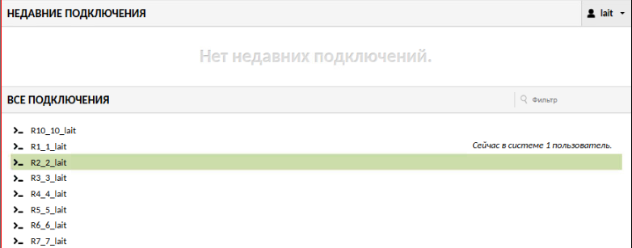

I think I told you everything, here you need to try how convenient it will be or not, unfortunately we are not allocated money for such things, so we have to make do, earlier it was 80+ eve, now one and 100 forwarded trunk VLANs.
Saved on disk resources, we've been using it for a month now, everything is fine.
Of course, I won't support it on a permanent basis, it would drive me crazy, it took me almost a month to understand what's going on here and how to make tiny changes.
If you have any questions, you can find my git contact in the LICENSE file in unetlab.

