[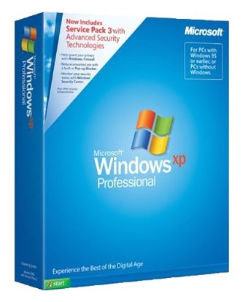](https://kickass.so/confirm/url/aHR0cDovL3ZpcnR1YWx1cGxvYWQubmV0L3ZpZXdlci5waHA/ZmlsZT0wMzEyOTczOTgwNTY2MTUxOTY4MC5qcGc=/)  
  
+-----------------------------------------------------------------------------------------------+  
| Windows XP Professional SP3 Dec 2014 + SATA Drivers [TechTools] |  
+-----------------------------------------------------------------------------------------------+  
This is the original Windows XP Professional SP3 (32-bit) ISO from Microsoft. Including Microsoft updates until 10.12.2014, Internet Explorer 8, Adobe Flash Player 16 and SATA drivers.  
  
- Declaration: Some might say that Microsoft no longer supports Windows XP. Well, that's true! Then what's new in this release? Here you go:  
  
* Added: Security Update for Internet Explorer 8 for Windows XP (KB2964358). Released: 01.05.2014  
* Updated: Windows Malicious Software Removal Tool - November 2014 (KB890830). Released: 10.12.2014  
* Updated: Adobe Flash Player ActiveX Control (16.0.0.235). Released: 10.12.2014  
  
- This release is the best you could find on the net, because Maherz made it just simple:  
  
* NO tweaks or add-ons.  
* NO additional programs and software added.  
* NO graphics, scripts and wallpapers added or changed.  
* NO serial needed during installation, the key is already inserted.  
* Activated and passes Microsoft Windows Genuine validation test.  
* It's the original image from Microsoft except added updates, IE8, Adobe Flash Player (16.0.0.235) and SATA drivers!  
* Windows Messenger, MSN Explorer and Internet Explorer 6 were removed.  
  
- System requirements:  
  
* Pentium 233-megahertz (MHz) processor or faster (300 MHz is recommended).  
* At least 64 megabytes (MB) of RAM (128 MB is recommended).  
* At least 1.5 gigabytes (GB) of available space on the hard disk .  
* Video adapter and monitor with Super VGA (800 x 600) or higher resolution.  
  
  
+----------------+  
| How to use |  
+----------------+  
-Burn ISO to CD/DVD & Install  
Enjoy!!   
  
Support topic: [http://techtools.net/forum/viewtopic.php?f=12&t=71170](https://kickass.so/confirm/url/aHR0cDovL3RlY2h0b29scy5uZXQvZm9ydW0vdmlld3RvcGljLnBocD9mPTEyJmFtcDt0PTcxMTcw/)  
  
Come check out our [Site](https://kickass.so/confirm/url/aHR0cDovL3d3dy50ZWNodG9vbHMubmV0/)  
We have instant-chat, forums, request section, account registration, over 64,000 users, we also do software, music, movies, E-Books, just about everything!  
  
Please Follow us on [Facebook](http://www.facebook.com/ThumperDC). Thank you!  
[](http://www.facebook.com/ThumperDC)

Serials, if needed :

MR49R-DRJXX-M6PX2-V96BF-8CKBJ  
DFYXB-8FR68-FK2DX-Y2RDR-M4C6M  
CD87T-HFP4C-V7X7H-8VY68-W7D7M  
C4FPJ-HQCGP-QD3XC-2JF34-FT8Y6